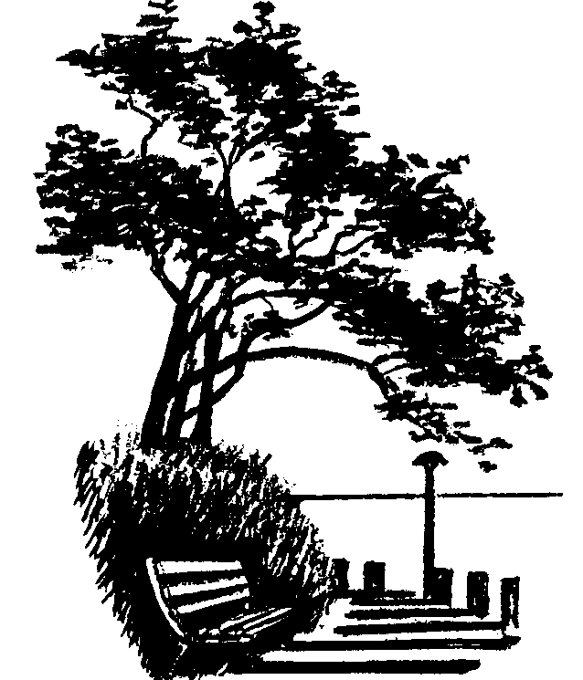WBRA MEMBERSHIP SURVEY

The West Bay Residents Association (WBRA) is a registered society that promotes the interests of the West Bay community, undertakes initiatives that contribute to the vibrancy and resiliency of our community, and shares information regarding events and issues important to West Bay residents.

Any resident of the West Bay neighbourhood, 18 years and over, is eligible to register as a member of the Society. All registered members will receive updates, information and newsletters. In addition, registered members, who have paid an annual membership fee, are eligible to vote during General and Annual General meetings.

As we enter into 2022, we ask that you take part in this short survey to help us evaluate how well we are meeting the needs of our members and the community so that we can identify where improvements can be made.

Please forward your completed survey to WestBayResidentsAssoc@shaw.ca or drop it off at 980 Dunsmuir Road by April 10, 2022.

All responses to this survey are anonymous, and will only be used by the WBRA to help it better serve our West Bay neighbourhood.

- Are you a registered member of the West Bay Residents Association (WBRA)?
____ YES
____ NO

- Are you a voting member of the WBRA?
____ YES
____ NO

- If you are not a member, would you consider becoming a member?
____ YES
____ NO
____ MAYBE

- Would you encourage others to become members of the WBRA?
____ YES
____ NO
____ MAYBE

- Are you familiar with the following:
  - The WBRA and its mandate
____ YES
____ NO
  - The WBRA Facebook, Website and Newsletter sites
____ YES
____ NO
  - The activities and initiatives of the WBRA
____ YES
____ NO

- WBRA uses email, Facebook, website and newsletter to share information about the happenings in West Bay. How do you prefer to receive your information?
Choose more than one option if applicable.
  - ____ Email
  - ____ Facebook
  - ____ Website
  - ____ Newsletter
  - ____ Other (please explain)

- What do you see as the role of the WBRA? Please mark all that apply:
  - ____ Advocating for adherence to the Official Community Plan (OCP) and the West Bay Design Guidelines
  - ____ Maintaining good relations between WBRA and the Esquimalt Township Council and staff
  - ____ Distributing information about development activities in West Bay
  - ____ Liaising with other resident associations
  - ____ Advocating for diverse housing within West Bay
  - ____ Advocating for protection of heritage buildings and other spaces
  - ____ Advocating for a diverse and inclusive neighbourhood
  - ____ Other (Please explain)

- How satisfied you are with the WBRA’s responsiveness to West Bay area issues and concerns?
____ Very satisfied
____ Satisfied
____ Neither satisfied nor dissatisfied
____ Somewhat dissatisfied
____ Dissatisfied
____ Very dissatisfied

- Please identify ways in which the WBRA could improve and be more responsive to West Bay issues and concerns.

- What other activities and or services would you like the WBRA to provide to the community?

Additional Comments:

Thank you for participating in our survey. Your input will serve to benefit the operations of the society, and ultimately strengthen the WBRA as we continue to grow our membership.

